Project Design Phase-II
Data Flow Diagram & User Stories
System Architectural Logic and Functional Requirements Mapping
Date | 12 July 2026
Team ID
Project Name | Darshan ease
Maximum Marks | 4 Marks

Data Flow Diagrams (DFD)
A Data Flow Diagram (DFD) is a traditional visual representation of the informational dynamics within a system architecture. A neat and clear DFD can depict the right amount of system requirements graphically. It shows how data enters and leaves the system, what specific logic changes the informational state, and where data is persistently stored across collections.
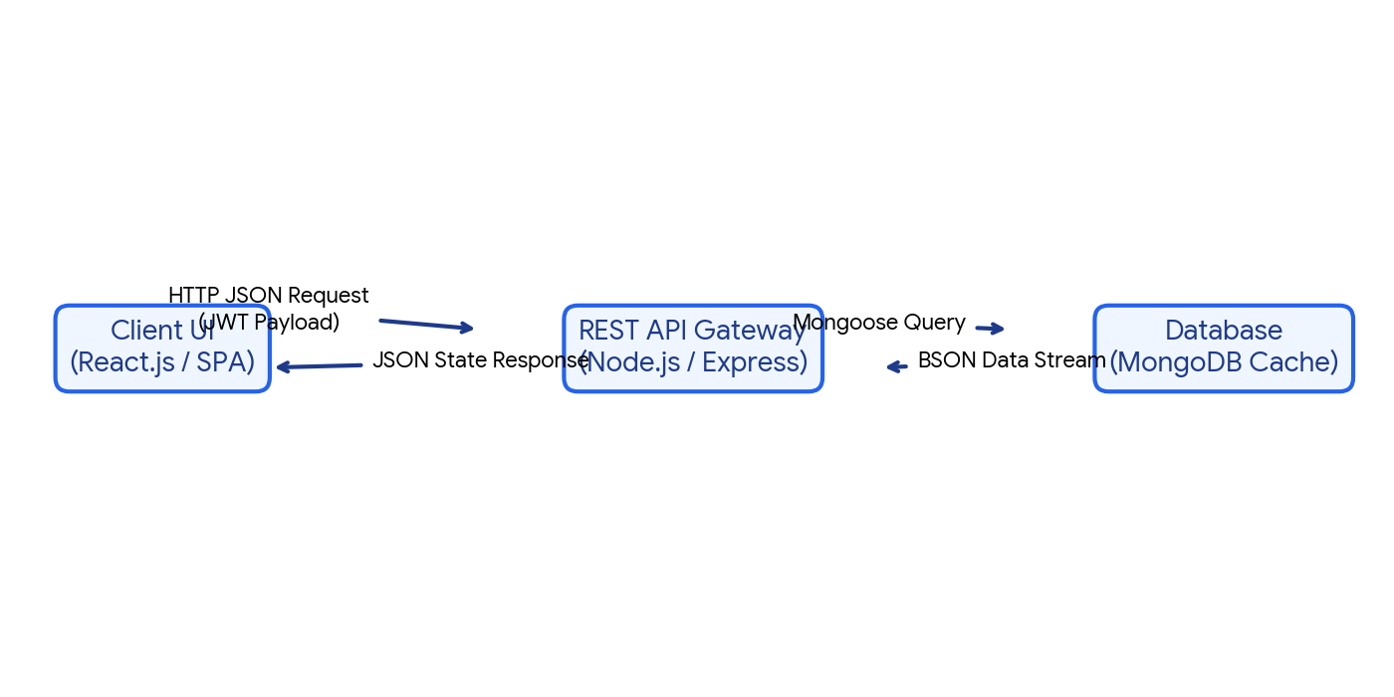
Figure 1.1: Functional Data Flow Diagram Framework for my-mern-project REST endpoints and collections.
Core MERN Stack System Data Sequences:
- User Interactivity & Routing: The user interacts with the React single-page application dashboard layer, configuring authorization context properties.
- API Gateway Handshake: The client bundle routes state-action data dynamically over HTTP network tunnels to Express endpoints.
- Asynchronous Processing Pipeline: Node.js handles concurrent thread worker operations, running request data schemas against validation logic guards.
- Persistent Storage Serialization: Mongoose ODM establishes connectivity to the cloud MongoDB collections instance to securely commit or pull full document payloads.

User Stories Specifications Matrix
Use the multi-tier structured matrix template layout below to define requirements verification pipelines across all designated system roles:
User Type | Epic Category | Story ID | User Story / Functional Task Description | Acceptance Criteria | Priority | Target Release
Web Customer | Registration | USN-1 | As a user, I can register for the platform using valid credentials. | Dashboard access is granted post validation. | High | Sprint-1
Web Customer | Registration | USN-2 | As a user, I receive a verification message upon signup completion. | SMTP token received successfully. | High | Sprint-1
Web Customer | Registration | USN-3 | As a user, I can log in using external third-party OAuth providers. | Dashboard logs details via social ID token. | Low | Sprint-2
Web Customer | Authentication | USN-4 | As a user, I can log in using my email & password to maintain a session. | Server yields standard secure JWT. | High | Sprint-1
Client Executive | Data Review | USN-5 | As an agent, I can filter dynamic transaction queues accurately. | Table drops records instantly on selection. | Medium | Sprint-2
System Admin | User Control | USN-6 | As an administrator, I can modify user role privileges dynamically. | BSON updates commit across database nodes. | High | Sprint-3
System Admin | System Audits | USN-7 | As an administrator, I can look up API validation fault exceptions. | Error codes index cleanly to local logs. | Medium | Sprint-3

